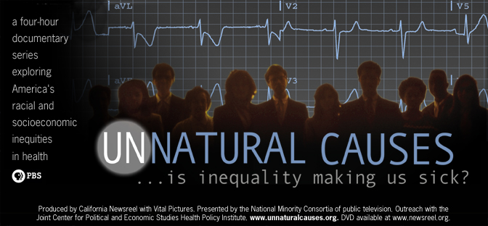

[INSERT ORGANIZATION NAME]
requests your company at a special screening of
UNNATURAL CAUSES: Is Inequality Making Us Sick?

Date:
Time:
Place:

The screening will be followed by a forum addressing [INSERT EVENT DESCRIPTION]
Speakers include:
- [INSERT NAME]
- [INSERT NAME]
- [INSERT NAME]

A reception will follow.

Please RSVP to [INSERT CONTACT INFORMATION] by [INSERT DATE]
For more information, please visit [INSERT WEB SITE]

